## **Transition to Microsoft Azure Proposal**

"Paws & Whiskers" is a growing pet shop that aims to-

Improve its operations by understanding data insights using sales, customer information, and inventory data. Currently, the data is collected manually or stored in spreadsheets.

This approach limits efficiency, scalability, and the ability to make informed business decisions.

## Transitioning to Microsoft Azure helps the business -

## into cloud-based solution for data storage, analysis, and reporting.

## to meet the goals meeting compliance with UK data regulations.

## **Data Laws and Regulations**

### **GDPR Compliance**

The General Data Protection Regulation (GDPR) governs how personal data is collected, processed, and stored within the UK and EU. Paws & Whiskers must comply with GDPR to ensure how personal data is collected, processed and stored within the UK and EU. Key aspects include:

1. **Lawful Basis for Processing:** Inorder to improve customer service or marketing campaigns, customer data must only be collected for lawful purpose**.**
2. **Data Minimisation:** E.g.: email addresses, purchase history and pet preferences should be collected.
3. **Transparency and Rights:** How the customer data is used through clear privacy notices should be informed to the customers. They should have access to their data, along with the ability to correct any inaccuracies or request it to be deleted as is their right.

More information can be found here in the below link - Full GDPR EU Bill

- https://gdpr-info.eu/

### **Data Protection Act (DPA) 2018** includes Breach reporting(data breaches should be reported to Information commissioner’s office within 72 hours), security measures like encryption and multifactor authentication and accountability

### **How data should be collected, processed and secured -** Paws & Whiskers must document

Link to the official UK government website https://www.gov.uk/data-protection

### **Other Industry Standards**

* + **Paws & Whiskers should compliance with Payment Card Industry Data Security Standard (PCI DSS) if they process card payments.**
  + **Consumer Rights Act 2015 -** Data collected for marketing or service purposes must align with fair, transparent practices to protect customer rights.

**Azure Service Recommendations**

* **Data Storage Options**
  + **Azure Blob Storage**
    - Cost-effective and supports formats like CSV, JSON, and Parquet.
    - **Use Case**: Ideal for storing frequently accessed non-relational data.
    - Scalable storage for unstructured data
  + **Azure SQL Database**
    - **Use Case**: Perfect for tracking sales, managing inventory, and storing customer data.
    - Fully managed relational database for structured data (e.g., customer profiles, sales transactions, inventory records).
    - Supports advanced querying and integrates seamlessly with Power BI for reporting.
* **Data Analysis Tools**
  + **Azure Synapse Analytics**
    - Identifies trends, such as popular products and peak sales periods.
    - Advanced analytics for large-scale datasets, integrating sales and inventory data
  + **Azure Machine Learning**
    - Predicts inventory needs based on historical sales data.
    - Predictive analytics to understand customer behavior and recommend personalized products.
* **Data Integration and Automation**
  + **Azure Data Factory**
    - **Use Case**: Reduces manual data entry errors, saves time, and improves accuracy.
    - Automates data collection, transformation, and integration from various sources (e.g., in-store sales, online orders, supplier data).

**Data Types and Data Modelling**

* **Essential Data Types**:
  1. **Pet Inventory**: Types, availability, and sales trends.
  2. **Product Categories**: Food, toys, grooming, and accessories.
  3. **Customer Demographics**: Names, contact details, and pet preferences.
  4. **Transaction History**: Purchase dates, items, and payment methods.
* **Data Modelling Approach**:
  1. **Relational Model**:
     + **Categories Table**: CategoryID (Primary Key), Name
     + **Transactions Table**: Transaction (Primary Key), Customer (Foreign Key), Date, TotalAmount.
     + **Products Table**: Productid (Primary Key), CategoryID (Foreign Key), Name, Price, StockLevel.
     + . **Customers Table**: CustomerID (Primary Key), Name, Email, Phone, Address.
* **Entity Relationships**:
  1. Transactions link to customers &products.
  2. Products are categorized for reporting and inventory management.

Beow is the example data modelling structure together:

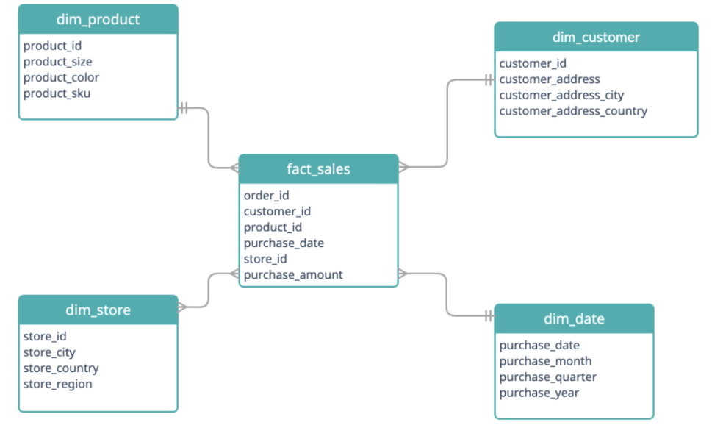

**Data Storage Formats and Structures in Azure**

**Additional Considerations**

**Data Storage Formats and Structures in Azure**

* **Parquet**: Optimized for analytics, reducing storage costs and enhancing query performance.
* **CSV**: Ideal for importing and exporting raw data due to its simplicity and broad system compatibility.
* **JSON**: Best suited for structured data, such as API integrations, offering flexibility in storing hierarchical information.

**Data Security and Encryption (GDPR & DPA 2018 Compliance)**

* Implement **Role-Based Access Control (RBAC)** to ensure only authorized personnel access sensitive data.
* Use **Azure Key Vault** for secure management of encryption keys.
* Enable **Transparent Data Encryption (TDE)** for Azure SQL Database to secure stored data.

### **Future Scalability**

• Seamless **Scalability** – As the business grows, Azure’s flexible infrastructure allows Paws & Whiskers to expand effortlessly

• Data**& Analytics Growth** – Increasing data volumes and advanced analytic needs use Blob Storage, SQL Database, and Synapse

• Global **Expansion Ready** – Azure simplifies international scaling, with GDPR compliance required in each new market.

**Conclusion**

* Moving Paws & Whiskers to Microsoft Azure ensures efficient data management.
* Azure’s integration, automation, and security ensure efficient data management and decision-making.
* Implementing GDPR-compliant practices and using Azure services helps streamline operations and drive future growth.
* This proposal enables Paws & Whiskers to drive digital transformation and stay competitive.